APPEAL APPLICATION FORM
FOR INTERVIEW ASSESSMENT RESULTS

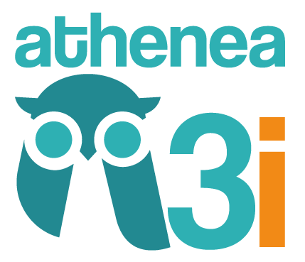
ATHENEA3i FELLOWSHIP PROGRAMME
SECOND CALL - 2018

ATHENEA3i
Attracting and Encouraging Triple 'I' Talent Mobility

Marie Skłodowska-Curie COFUND Actions

ATHENEA3i FELLOWSHIP PROGRAMME - SECOND CALL 2018 APPEAL APPLICATION FORM FOR INTERVIEW ASSESSMENT RESULTS

It is mandatory to complete and submit the Appeal Application Form for Interview Assessment Results in order for the appeal to be considered. Once the Appeal Application Form has been properly completed, it must be printed and signed by the applicant. This Form must be submitted as a single PDF file via this link: http://investigacion.ugr.es/pages/planpropio/p21athenea. In order to submit it, you need to enter in your account using the user and password provided you during the application process.
Please introduce your comments regarding the cause/s of appealing:
Comment section

4000 characters maximum with spaces

Proposal number*:
Name*:
Last name*:
Signature*:

Appeal Application Period: From 13 May 2019 to 21 May 2019 at 11:00h (Spanish time). Any appeal received after the deadline will not be accepted.

Applicants are responsible for ensuring that the file is uploaded correctly and that the contents are legible. In the event that the documents cannot be read properly, applicants will be unable to submit any further appeals.

